Most Worshipful Union Grand Lodge
Most Ancient & Honorable Fraternity
Free and Accepted Masons, Prince Hall Affiliated
Florida, Belize Central America, and St. Johns U.S.V.I. Jurisdictions, Inc

The Honorable Jeffery G. Jones, Most Worshipful Grand Master

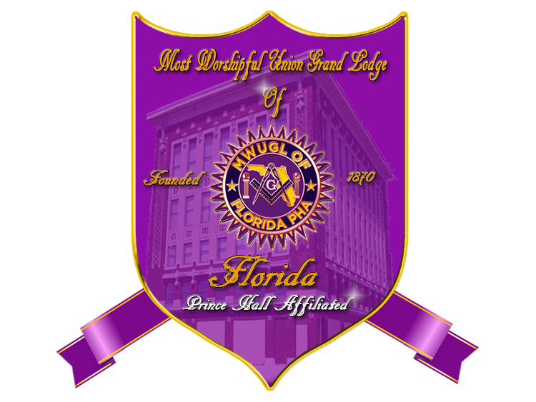

MEMBERSHIP PROGRAM

TABLE OF CONTENTS

PAGE 3: Program Explanation letter –This letter is provided to the members of the Lodge to explain how to distribute the interest meeting invitations.

PAGE 4: Invitation letter - This letter should be given to good men in the community, who may become contributing members of the lodge.

PAGE 5: Interest meeting Agenda – This is a brief agenda used to break the ice with the invitees. The rest of the meeting should be conducted as a “meet and greet” social.

PAGE 6 – 10: Interest Meeting Handout – Give this handout to the invitees during the beginning of the meeting. The document contains non-sensitive, Masonic info to aid in peeking interest.

PAGE 11: Background Check Form – The secretary should have this document on hand at the meeting. Give them out, only if an invitee requests information about joining.

PAGE 12-13: C andidate investigation sample questions – Sample questions should be used by the investigating committee to assess candidates for membership.

PAGE 14: Candidate Rejection Letter – Send to all rejected candidates.

PAGE 15: Candidate Orientation Agenda – Agenda should be used to prepare the candidate for the initiation, passing, and raising process.

PAGE 16: Program Instructions

See additional attachments for candidate study and proficiency materials.

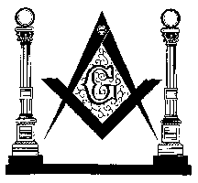
Any Masonic Lodge #001
Prince Hall Affiliated Masons
Mailing Address
Your City Fl. XXXXX
Bro. John Doe, Worshipful Master

Re: Interest Meeting Cover Letter

Dear Name,

With the permission of the Most Worshipful Union Grand Lodge, we are piloting a new program formulated to increase membership in the Masonic Jurisdiction of Florida. This program is designed to strategically find upright men in the community who, for whatever reason, never inquired about the qualifications required to become a Mason.

To accomplish this feat, two (2) invitations to an upcoming interest meeting are included in this packet. I am asking that you hand-deliver invitations (Do not mail) on or before Date XX/XX/XXXX. Please be extremely selective; do not hand out these invitations lightly. Only invite qualified individuals who will contribute to the mission and vision of the Grand Lodge and your local lodge and to the betterment of the community. Above all, before delivering an invitation, ask yourself whether this individual may be trusted in the lodge and around your family. After making an informed decision, govern yourselves accordingly.
DO NOT DISTRIBUTE

An interest meeting will be scheduled on Day, Date XX/XX/XXXX, beginning at 7:00pm. If possible, brothers who distribute invitations should be present at the interest meeting. The meeting will be informal, and sensitive Masonic information will not be divulged. The primary focus is to provide general facts about who we are and what we do. Additionally, during the meeting, take time to get to know the men you have selected. When our guests arrive, make a concerted effort to be hospitable and to ensure that they feel welcomed. Our ultimate desire is to make a first impression which is not easily forgotten.

If you have any questions regarding this program, please contact Bro. XXXXX XXXXX. Bro last name is the chair of this committee, and he is assisting me with coordinating these efforts. He may be reached at Phone Number XXX-XXX-XXXX.

I look forward to your enthusiastic participation in one of our most important programs. With your assistance, I’m certain that we will be successful!

Fraternally yours,

Brother John Doe
Worshipful Master

Prince Hall Masons ~ Making Good Men Better Men
Any Masonic Lodge #447 is a subordinate lodge working under the protection of the Most Worshipful Union Grand lodge ~ Most Ancient and Honorable Fraternity Free and Accepted Masons Prince Hall Affiliated of Florida, Belize Central America, & the U.S.V.I., Jurisdiction, Inc
The Honorable Jeffery G. Jones, Most Worshipful Grand Master.
Any Masonic Lodge #001
Prince Hall Affiliated Masons
Mailing Address
Your City Fl. XXXXX
Bro. John Doe, Worshipful Master

Re: Prince Hall Interest Meeting Invitation

Dear Mr. __________________________,

You have been identified as one who may possess the typical qualities of men in our esteemed organization. As such, it gives me great pleasure to invite you to an informal “Meet and Greet” session to be held at the Masonic lodge on (day)__xxxxxx___ (date)__xxxxxxx______________, 2020. The location of the session is Your Building Address. The session will begin promptly at 7:00 p.m. Refreshments will be served shortly thereafter. Attire for the evening is business casual.
PERSONAL INVITATION

The purpose of the “Meet and Greet” is to foster an opportunity for you to receive information about Masonry in the Jurisdiction of Florida and for our membership to get to know you. Should you decide to attend, please call the enclosed number to advise us of your intentions. Additionally, after the “Meet and Greet”, please be advised that there is no obligation for you to join our organization. Likewise, there is no obligation for the lodge to accept your petition, if submitted. However, should you decide not to attend, we simply ask that you discard this letter, and notify the individual who gave it to you.

Finally, this invitation is afforded to you because of your personal qualities and community involvement. It is not transferrable to other persons. To this end, please do not bring additional persons to the session. The lodge reserves the right to deny admittance to those who have not been invited.

On behalf of the members of Any Masonic Lodge #001, congratulations on receiving an invitation to our “ Meet and Greet.” I look forward to personally meeting you at the event.

Sincerely,

Brother John Doe, Worshipful Master
Your Lodge name and number

Please call Brother xxxxxx xxxxxxx (XXX) XXX-XXXX to RSVP

Please call Brother xxxxxx xxxxxx no later than (date) __Month, Day, Year_________________

Prince Hall Masons ~ Making Good Men Better Men
Pride of Palm Beach Lodge #447 is a subordinate lodge working under the protection of the Most Worshipful Union Grand lodge ~ Most Ancient and Honorable Fraternity Free and Accepted Masons Prince Hall Affiliated of Florida, Belize Central America, & the U.S.V.I., Jurisdiction, Inc
The Honorable Jeffery G Jones, Most Worshipful Grand Master.

PRIDE OF PALM BEACH MASONIC LODGE #447
CANDIDATE INTEREST MEETING
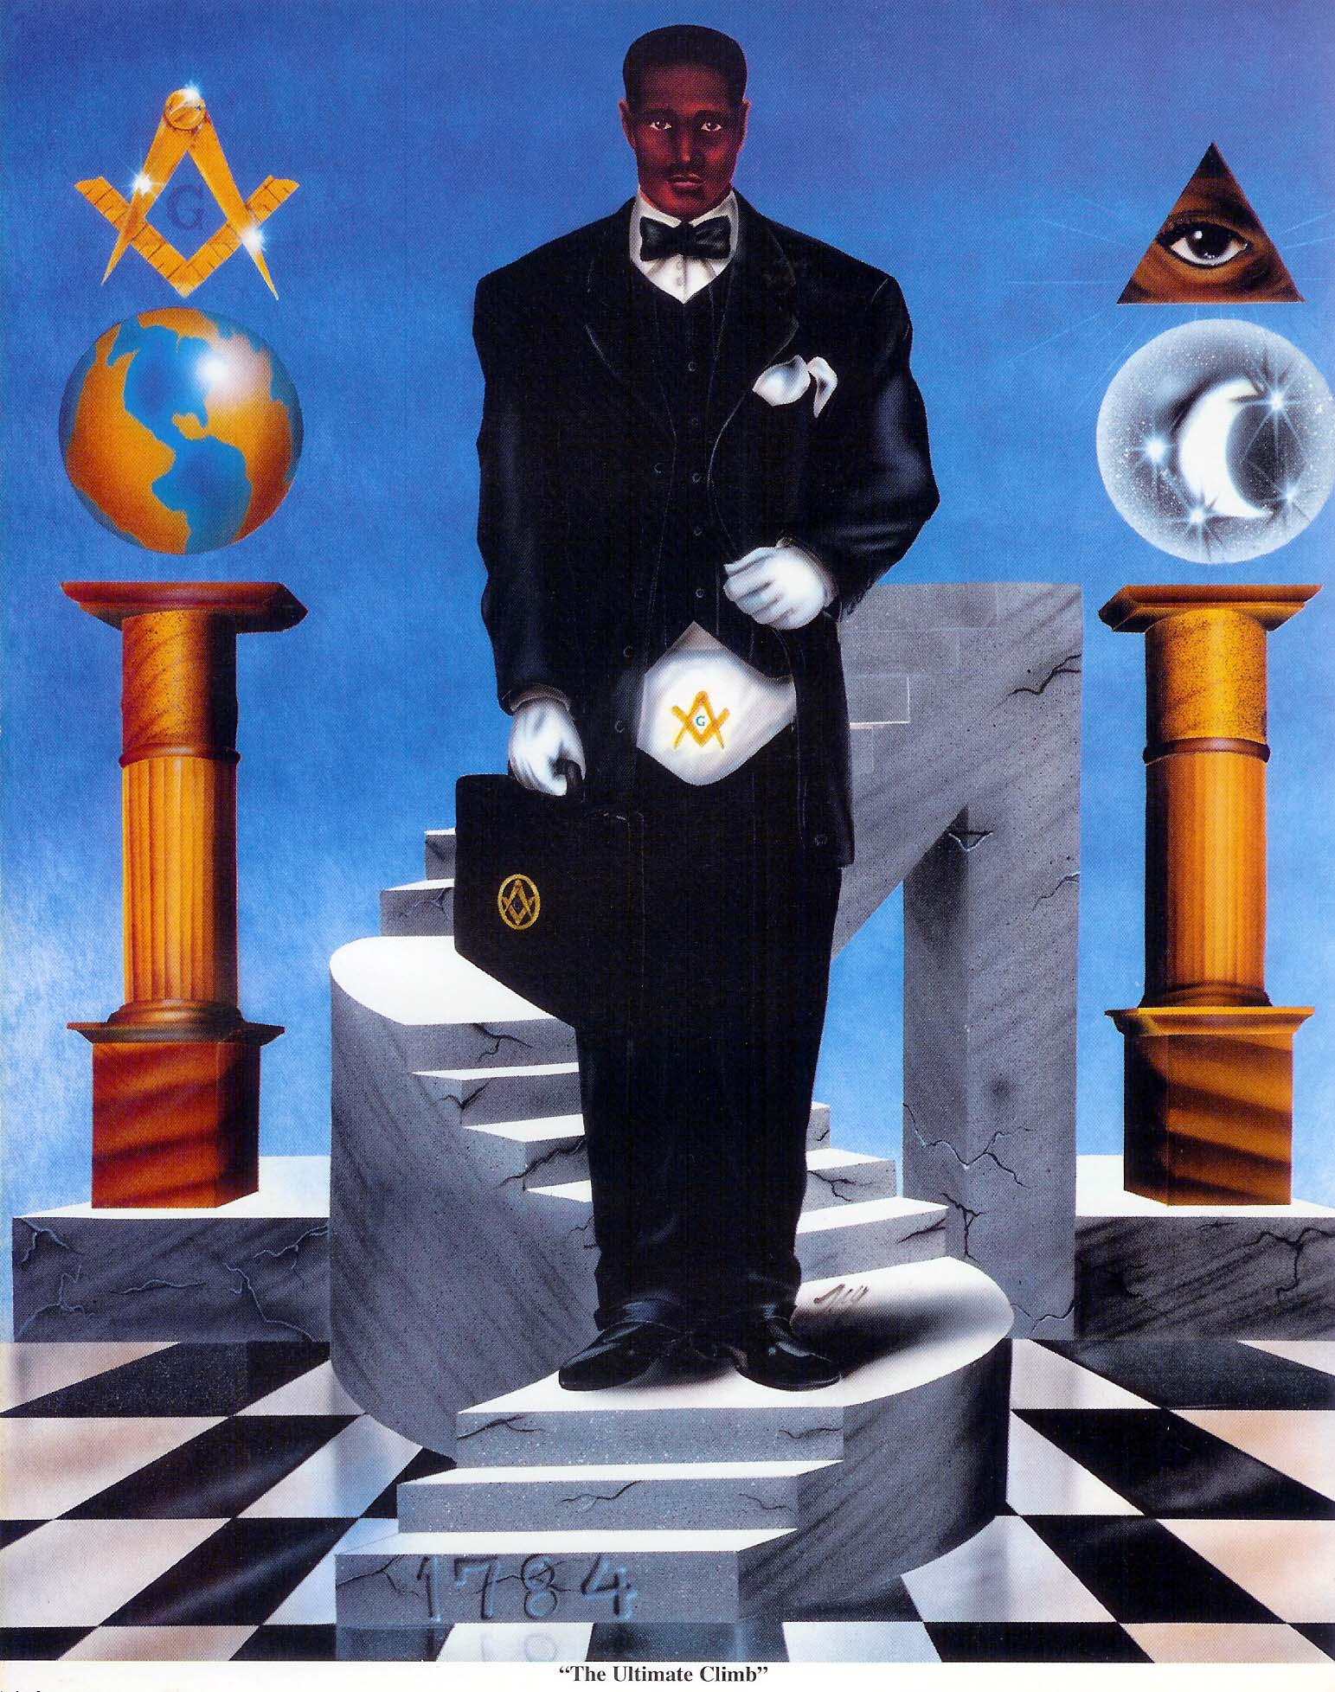
Bro. John Doe
Worshipful Master

Facilitator: PM Xxxxxxx Xxxxxxx

4:00pm Prayer PM Xxxxxxx Xxxxxxxx

4:05pm Welcome JW Xxxxxxx Xxxxxxx

4:10pm Introductions SW Xxxxxx Xxxxxxx

4:20pm Why Were Here PM Xxxxxxx Xxxxxxx

4:30pm Who We Are / What We Do PM Xxxxxxx Xxxxxxx

5:00pm Closing WM John Doe

Questions & Answers

Grace

FOOD AND DRINKS SERVED

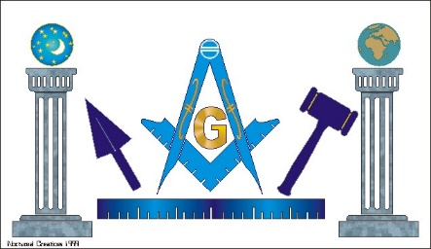

MASONIC MEET AND GREET
Masonic Information Handout
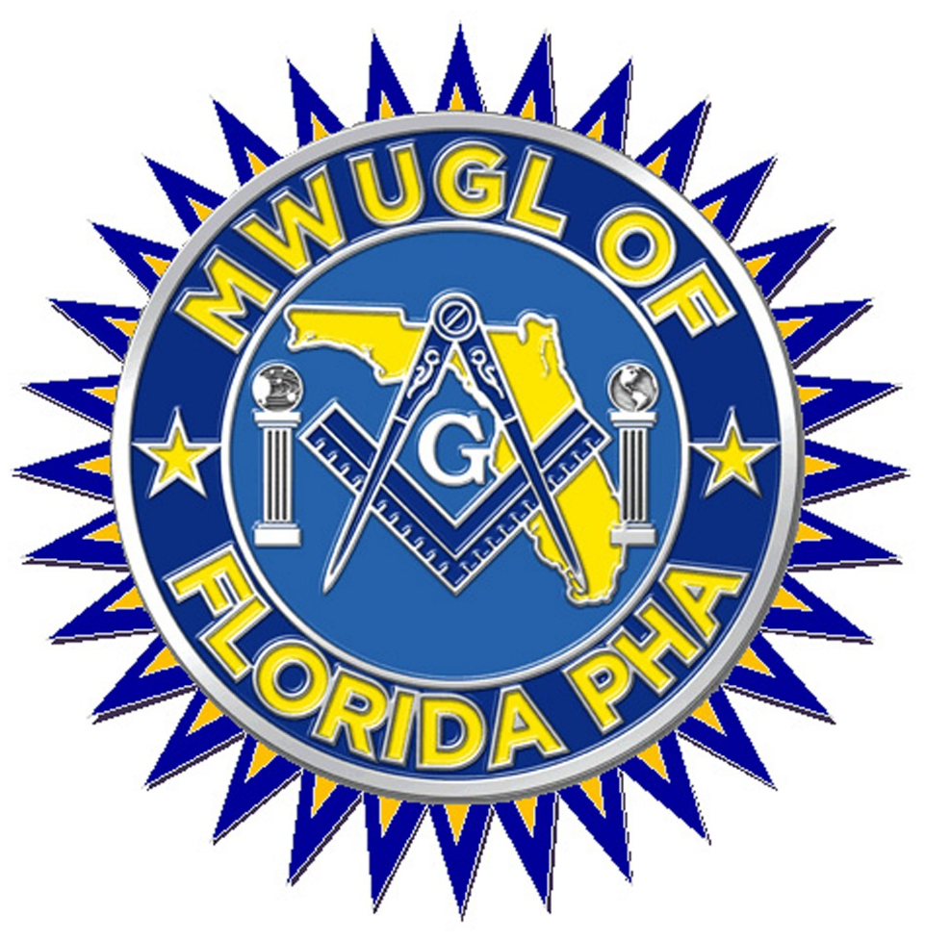

ABC Masonic Lodge #001
ANY CITY, Florida ~ District #XX
Bro. JOHN DOE, Worshipful Master

Working Under the Protection of

The Most Worshipful Union Grand Lodge
Most Ancient & Honorable Fraternity
Free and Accepted Masons, Prince Hall Affiliated
Florida, Belize Central America, and St. Johns U.S.V.I. Jurisdictions, Inc

The Honorable Jeffery G. Jones, 33° KYCH
Most Worshipful Grand Master

Have You Ever Considered Becoming a Mason?
Freemasonry is the oldest, largest Fraternity in the world. Its members have included Kings, Presidents, Prime Ministers, Statesmen, Generals, Admirals, Supreme Court Justices, corporate CEOs, opera stars, movie stars, civil-rights leaders, and probably, your next-door neighbor.

Masonry is always ready to welcome good men into the Fraternity.

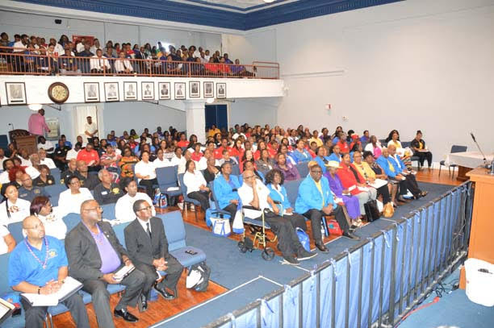

Do you believe that there is such a thing as honor, and that a man has a responsibility to act with honor in everything he does?
Masons teach that principle. We believe that a life not founded on honor is hollow and empty -- that a man who acts without honor is less than a man.
Do you believe in God?
No atheist can be a Mason. Masons do not care what your individual faith is -- that is a question between you and your God -- but we do require that a man believe in a Supreme Being.
Are you willing to allow others the same right to their own beliefs that you insist on yourself?
Masonry insists on toleration -- on the right of each person to think for himself in religious, social and political matters.
Do you believe that you have a responsibility to leave the world a better place than you found it?
Masonry teaches that each man has a duty not only to himself but to others. We must do what we can to make the world a better place. Whether that means cleaning up the environment, working on civic projects, or helping children to walk or read or see -- the world should be a better place because we have passed through it.
Do you believe that it is not only more blessed to give than to receive, it's also more fun?
Masons are involved with the problems and needs of others because we know it gives each of us a good feeling -- unlike any other -- to help. Much of our help is given anonymously. We're not after gratitude, we're more than rewarded by that feeling which comes from knowing we have helped another person overcome some adversity, so that their life can go on.
Are you willing to give help to your Brothers when they need it, and to accept their help when you need it?
Masonry is mutual help. Not just financial help (although that's there, too) but help in the sense of being there when needed, giving support, lending a sympathetic ear.
Do you feel that there's something more to life than just financial success?
Masons know that self-development is more precious than money in the bank or social position or political power. Those things often accompany self-development, but they are no substitute for it. Masons work at building their lives and character, just as a carpenter works at building a house.
Do you believe that a person should strive to be a good citizen and that we have a moral duty to be true to the country in which we live?
Masons believe that a country is strong so long as freedom, equality, and the opportunity for human development is afforded to all. A Mason is true to his government and its ideals. He supports its laws and authority when both are just and equitably applied. We uphold and maintain the principles of good government, and oppose every influence that would divide it in a degrading manner.
Do you agree that man should show compassion for others, that goodness of heart is among the most important of human values?
Masons do. We believe in a certain reference for living things, a tenderness toward people who suffer. A loving kindness for our fellow man, and a desire to do right because it is right. Masonry teaches that although all men are fallible and capable of much wrong, when they discover the goodness of heart, they have found the true essence of virtue. Masonry helps men see their potential for deep goodness and virtue.
Do you believe that men should strive to live a brotherly life?
Masons see brotherhood as a form of wisdom, a sort of bond that holds men together -- a private friendship that tells us we owe it to each other to be just in our dealings and to refuse to speak evil of each other. Masons believe a man should maintain an attitude of good will, and promote unity and harmony in his relations with one another, his family and his community. Masons call this way of life believing in the Brotherhood of Man. It really means that every Mason makes it his duty to follow the golden rule. This is why Masonry has been called on of the greatest forces for good in the world.
If you answered "YES" you should consider becoming a Mason.
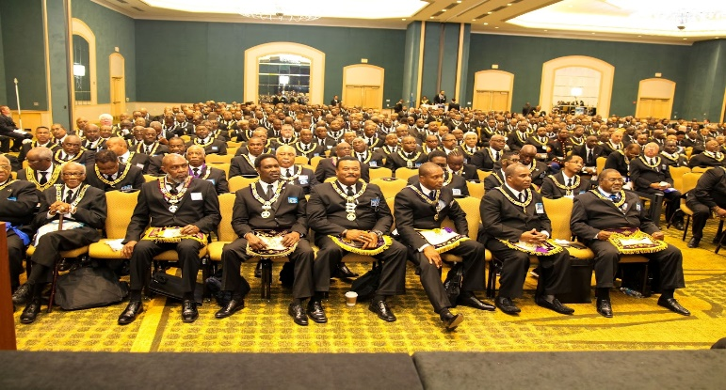

Freemasonry offers much to its members -- the opportunity to grow, the chance to make a difference, to build a better world for our children. It offers the chance to be with and work with men who have the same values and ideals -- men who have answered "YES" to these questions.

It's easy to find out more. Just find a Mason and ask him about Masonry. You probably know several Masons. Perhaps you've seen the Square and Compasses like the one below or on a pin or tack or bumper sticker. If you know where the lodge is in your community, stop by or look up the number
in the phone book and ask for the secretary of the lodge. He'll be happy to help you. 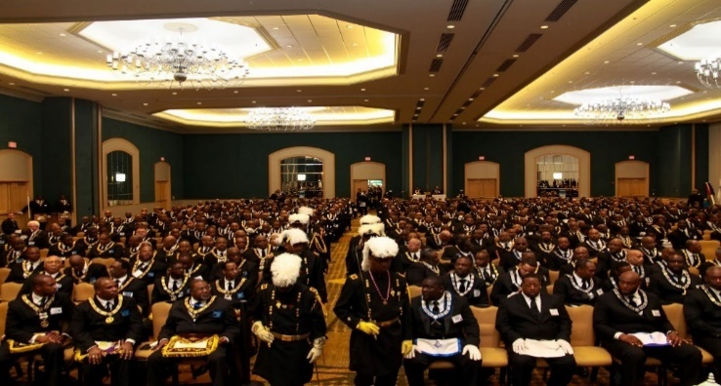



TEN REASONS TO BECOME A MASON

1. A place where you can confidently trust every person and trust your family with them also.
2. A place where, within moral and civil guidelines; free thought, free speaking and the spiritual growth of man, can grow into its fullest potential.

- A place to meet outstanding individuals from all walks of life, that a person would not otherwise have had the opportunity to know and call brother.
- A place to be part of an organization which has for its principal tenets – Brotherly Love, Relief and Truth.

5. A place that provides self-development opportunities, leadership training and experience, and to improve public speaking skills.
- A place you can go to seek support as well as give it.

7. A place where moral virtues are taught and through these teachings a regular reinforcement of the moral virtues is experienced.
8. A place to spend time with a group of brothers, who by acting as good men, make me want to become a better man. Not better than others, but better than I would have otherwise been.

9. A place to become better equipped to serve Church and community.
10. A place to meet with established members of the community and to become a part of the community.

FAMOUS PRINCE HALL MASONS

- Thurgood Marshall, Associate Justice, U.S. Supreme Court
- Alex Haley, author
- Booker T. Washington, educator/founder Tuskegee Institute
- Charles B. Rangel, U.S. Congressman New York
- Louis Stokes, U.S. Congressman Ohio
- William "Count" Basie, orchestra leader/composer
- Nathaniel "Nat King" Cole, American pianist and singer
- W.E.B. DuBois, educator/author/historian
- Edward Kennedy "Duke" Ellington, orchestra leader/composer
- Medger Wiley Evers, civil rights leader
- James Herbert "Eubie" Blake, composer/pianist
- Andrew Young, former mayor of Atlanta
- Thomas Bradley, mayor of Los Angeles, California
- Sugar Ray Robinson, mid/light heavy boxing champion
- John H. Johnson, publisher EBONY and Jet magazines
- Carl B. Stokes, first Black elected mayor, Cleveland, OH
- Robert Sengstacke Abbott, founder/publisher CHICAGO DEFENDER
- Richard Allen, founder/first bishop AME Church
- Matthew Henson, explorer
- Daniel "Chappie" James, general U.S. Air Force
- James Forten, abolitionist/manufacturer
- Timothy Thomas Fortune, journalist
- Richard D. Gidron, president, Dick Gidron Cadillac
- William C. Handy, composer
- Augustus F. Hawkins. U.S. Congressman California
- Lionel Hampton, orchestra leader/composer
- Benjamin L. Hooks, Former Executive Director NAACP
- Benjamin Mays, educator/former president Atlanta University
- Ralph H. Metcalfe, Olympic champion
- A. Phillip Randolph, founder/ first president, International Brotherhood of Sleeping Car Porters
- Egbert Austin "Bert" Williams, actor/ comedian
- Harry A. Williamson, author/Masonic historian
- Scottie Pippen, #33, Chicago Bulls / Forward
- Rev. Jesse Jackson, Harmony Lodge No. 88, Chicago, Illinois
- Leon Higginbothm, Jr. 33', Campbell-Wash-Joppa Lodge No 37 in Philadelphia, Pennsylvania
- Bro. Emanuel Cleaver of Eureka Lodge No. 170, Kansas City Missouri Mayor
- Bro. John H. Johnson 33, publisher, chairman and CEO of Johnson Publishing Company
- Civil Rights Leader, Rev. Al Sharpton under the Jurisdiction of New York
- Former U.N. Ambassador and Atlanta Mayor Bro. Andrew Young, St. James Lodge No. 4, Atlanta, Georgia
- Bro. Kweisi Mfume, President and CEO of the NAACP and a member of Mount Olive Lodge No. 25, Baltimore, Maryland
- John Robert Lewis, Civil Rights Leader and United States Congressman
MOST WORSHIPFUL UNION GRAND LODGE
MEMBERSHIP CANDIDATE INFORMATION FORM

NAME ____________________________________________________________________________________________________
LAST FIRST MIDDLE (FULL)
LIST ANY ALIASES ________________________________________________________________________________________
(SEPERATE MULTIPLE ALIASES BY COMMAS)
DATE OF BIRTH _______________________ CURRENT AGE __________ SS#____________________________
MM/DD/YY LAST 4 DIGITS
HOME ADDRESS ___________________________________________________________________________________________
STREET CITY STATE ZIP CODE
IF LESS THAN (6) MONTHS, LIST ON LINE BELOW YOUR PREVIOUS ADDRESS
ADDRESS ________________________________________________________________________________________________
==== Info above will be used by background screening committee - Info below will be used by the local lodge investigation committee =====
MARITAL STATUS ______________________________________ HOW LONG ________________________
OCCUPATION _________________________________________________________________ HOW LONG? ______________
CURRENTLY EMPLOYED BY _______________________________________________________________________________
HOME PHONE: ______________________________ WORK PHONE: ____________________________
CELL PHONE: _____________________________ EMAIL ADDRESS: _______________________________________________
WHO RECOMMENDED YOU OR WILL VOUCH FOR YOUR CHARACTER? ________________________________________
DO YOU HAVE ANY FAMILY MEMBER(S) THAT IS/ARE A MASON(S)? _______________________
NAME OF FAMILY MEMBER(S)_____________________________________________________________________________
(SEPERATE MULTIPLE NAMES BY COMMAS)
DO YOU BELIEVE IN GOD? _____________
WHAT CHURCH ARE YOU A MEMBER OF? __________________________________________________
CURRENT HEALTH STATUS? CIRCLE ONE! EXCELLENT GOOD FAIR POOR
DO YOU HAVE ANY PHYSICAL INJURIES? IF YES EXPLAIN! ____________________________________________________
DO YOU HAVE ANY PHYSICAL LIMITATIONS? IF YES EXPLAIN! ________________________________________________
HAVE YOU EVER BEEN DECLARED MENTALLY INCOMPETENT? _______________________________________________
PHYSICALLY, ARE YOU A MAN OR OTHER? _________________________________
A $20.00 PROCESSING FEE MUST ACCOMPANY THIS QUESTIONNAIRE, THE FEE IS NON-REFUNDABLE.
LODGE CHECKS, CASHIERS CHECKS, OR MONEY ORDERS ONLY. NO PERSONAL CHECK ACCEPTED.
APPLICANTS SIGNATURE ________________________________________________________DATE _____________________
By Signing this form the applicant acknowledges the following:
All information submitted is true and accurate. The applicant authorizes the Most Worshipful Union Grand Lodge to conduct a legal and
professional background check for membership consideration.
Instructions: The applicant is to return the completed form with payment to the Lodge. The Local Lodge is to make a copy for its records. The
original is to be forwarded along with the fee to the Most Worshipful Union Grand Lodge.
To Be Completed by the :
Worshipful Master Name_______________________________________________(Please Print) Masonic Zone #___________ District #__________
Worshipful Master Contact Phone # (________) _________________________ Lodge Name____________________________________ #________
MAY ALSO USE THE OFFICIAL BACKGROUND CHECK FROM THE GRAND LODGE WEBSITE

CANDIDATE INTERVIEW SAMPLE QUESTIONS
CANDIDATES NAME: | INTERVIEW DATE:
QUESTION | COMMENTS
1. DO YOU BELIEVE IN GOD?
2. DO YOU BELIEVE IN THE HOLY TRINITY?
3. DO YOU FEEL YOU ARE A MAN OF STRONG, MORAL CHARACTER? IF YES, WHY?
4. WHEN WAS THE LAST TIME YOU HELPED SOMEONE? EXPLAIN
5. DO YOU FIND IT HARD TO APOLOGIZE TO THOSE WHOM YOU HAVE WRONGED?
6. HOW DOES YOUR SPOUSE/FAMILY FEEL ABOUT YOU JOING THIS ORGANIZATION?
7. ARE YOU CURRENTLY EMPLOYED?
8. HOW LONG HAVE YOU BEEN EMPLOYED BY YOUR CURRENT EMPLOYER?
9. HAVE YOU EVER BEEN CHARGED WITH A CRIME? IF YES, WAS IT A FELONY & WERE YOU CONVICTED?
10. HOW DO RATE YOUR HEALTH?
EXCELLENT, GOOD, FAIR, POOR
11. HAVE YOU EVER APPLIED FOR MASONIC MEMBERSHIP BEFORE NOW? IF YES, WHERE?
12. HAVE YOU EVER BEEN REJECTED FOR MASONIC MEMBERSHIP? IF YES, WERE YOU TOLD WHY?
13. WHY DO YOU WANT TO BE A MASON?
14. WHAT DO YOU EXPECT TO GAIN FROM YOUR MASONIC MEMBERSHIP?
15. WHAT DO HAVE TO OFFER TO THE MASONIC LODGE?
16. ARE YOU ABLE TO COMMIT YOURSELF TO MEETINGS ON YOUR LODGE MEETING NIGHTS?

Any Masonic Lodge #001
Prince Hall Affiliated Masons
Mailing Address
Your City Fl. XXXXX
Bro. John Doe, Worshipful Master

Date:____________

John Doe
Street Address
City, State Zip

Re: Lodge Membership Petition

Dear Mr. ______________________,

The members of the Any Masonic Lodge #001 would like to thank you for your interest in pursuing membership in our organization.

It is with sincere regret that we inform you that your petition has been rejected at this time. We sincerely hope that this minor setback in your pursuit of Masonic membership does not discourage you in any way. Please be advised that the members of this lodge simply require further evidence of your resolve to become a Mason. According to the guidelines of this lodge, you are eligible to resubmit your request for membership after a period of six (6) months. If you choose to reapply, you will be given every consideration.

We sincerely wish you the best in your pursuit of that which you seek.

Sincerely,

Any Lodge #447
Investigation Committee, Chairman

Cc Worshipful Master
Secretary
Investigation Committee Members

CLASS ORIENTATION AGENDA

PRAYER

HOW TO ADDRESS BROTHERS

EXPLAIN ALL INITIATION FEES AND DUES REQUIREMENT IN NOVEMBER

CLASS DURATION (90 – 120 DAYS)

SET MEETING NIGHTS WITH THE CLASS LEADER – RECOMMEND 2-3 NIGHTS PER WEEK (EXPRESS THAT SELF STUDY IS PARAMOUNT TO SUCCESS. MEETING NIGHTS ARE NOT STUDY NIGHTS)

ESTABLISH CLASS OFFICERS – Pres. Vice-Pres., Secretary, Treasurer, Chaplin, Sergeant-at-arms

EXCHANGE PHONE NUMBER BETWEEN CANDIDATES AND CLASS LEADER(S)

EXCHANGE EMAIL ADDRESSES

PROVIDE COPY OF EMAIL ADDRESSES TO LODGE SECRETARY & CLASS LEADER

ALLOW THE CLASS TO ESTABLISH A NAME (BIBLICAL IN NATURE)

SET A CLASS FUNDRAISING GOAL TO BE PRESENTED TO THE LODGE – (example. $1000 Minimum)

THINGS NEEDED FOR TRAINING – To Be Determined by the assigned Class Leader (i.e. bible, pen, pads, etc.)

QUESTIONS & ANSWERS

PROGRAM INSTRUCTIONS

- Worshipful Master should present each member of the lodge with One copy of the Program Explanation letter and Two copies of the Invitation letter.

- Each member should discard the Program explanation letter and hand deliver the invitation letter to two up-standing members of the community.

- Worshipful Master prepares the Agenda and appoints a facilitator for the “Meet and Greet” social at the lodge.

- Secretary should have on hand copies of the background check form in the event an application is requested by an invitee.

- Worshipful Master will appoint an investigation committee and set a date for candidate interviews.

- Lodge will vote on candidates after the interviews are conducted.

- Investigation Chairman will notify the approved candidates by phone, advising them of the Class Orientation dates.

- Investigation Chairman will notify the rejected candidates in writing.

- Worshipful Master will appoint a Class Leader/Instructor.

- The Class Leader will organize the class, follow the Class Orientation Agenda, and observe the study packet timeline for proficiency degree work.

- After the Candidate is raised, the Worshipful Master will assign a Master mason Mentor to each candidate who will guide him through the Master Mason Study Packet and remain his mentor being sure to stay in contact through the 1st Year of membership. A Mentor may have more than one Mentee.

